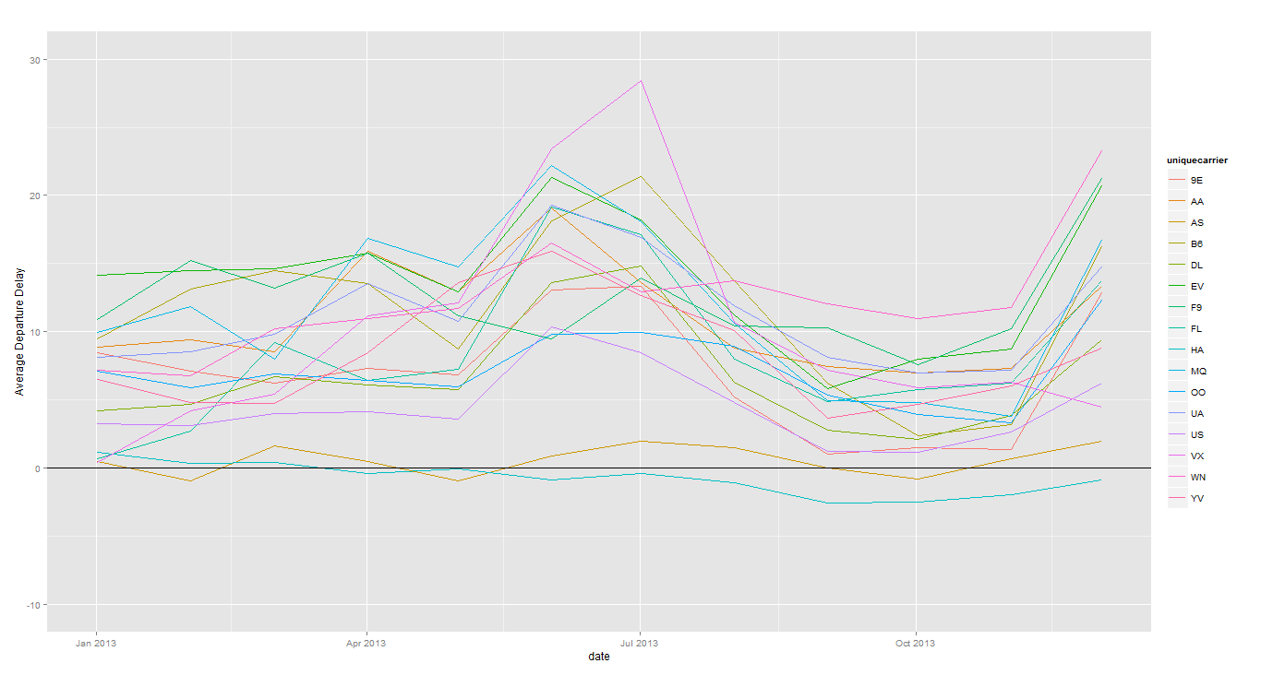

AVERAGE DEPARTURE DELAY 2013

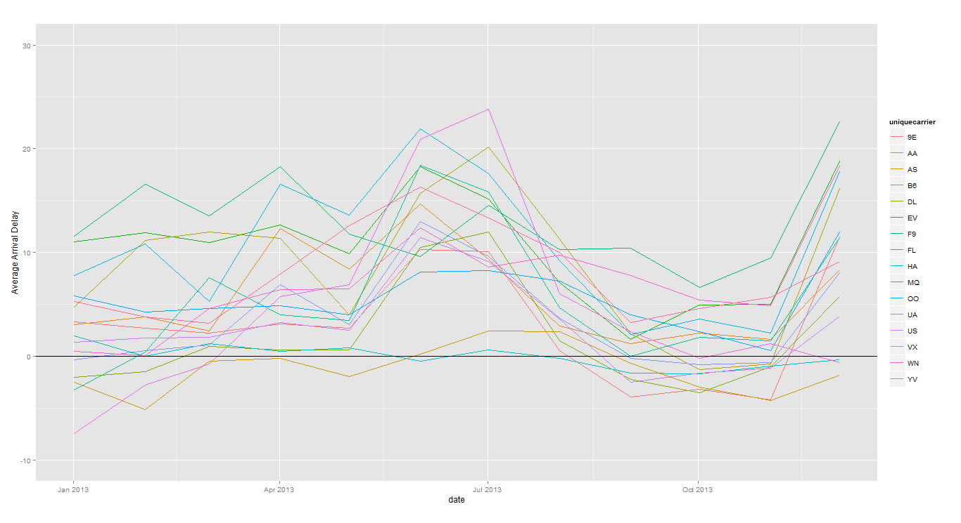

AVERAGE ARRIVAL DELAY 2013

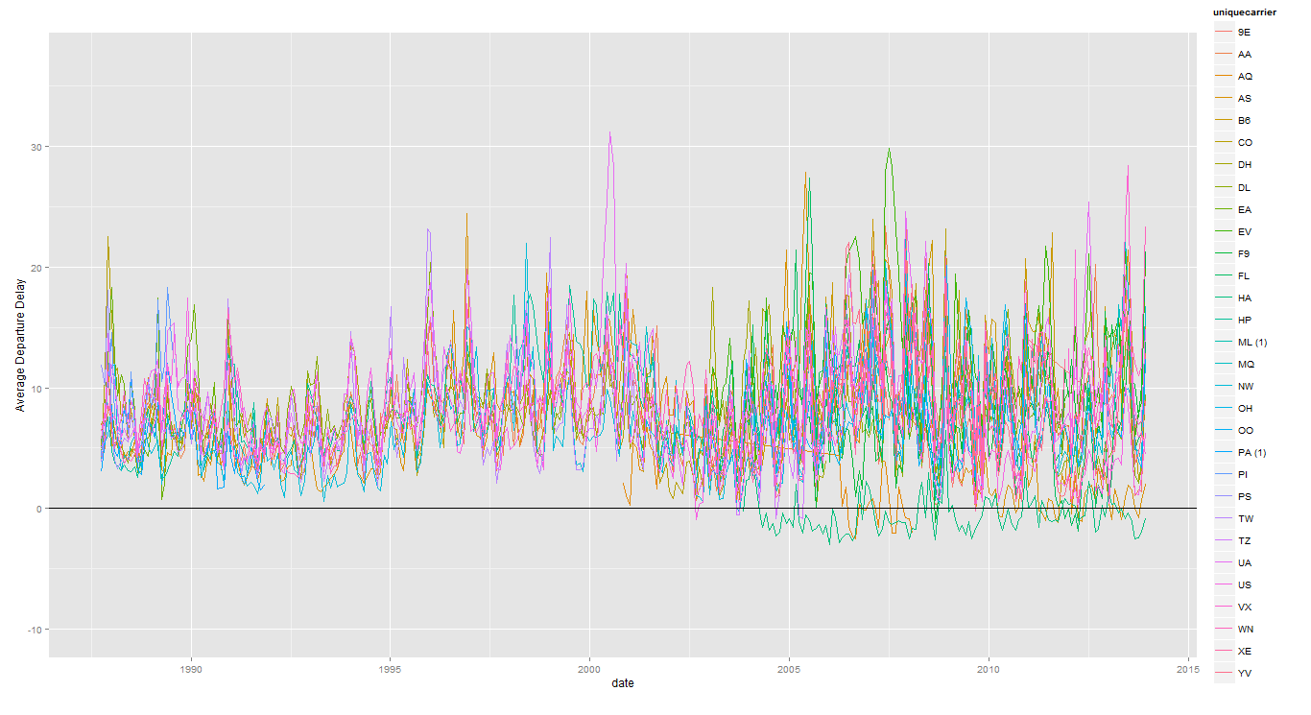

AVERAGE DEPARTURE DELAY ALL 27 YEARS

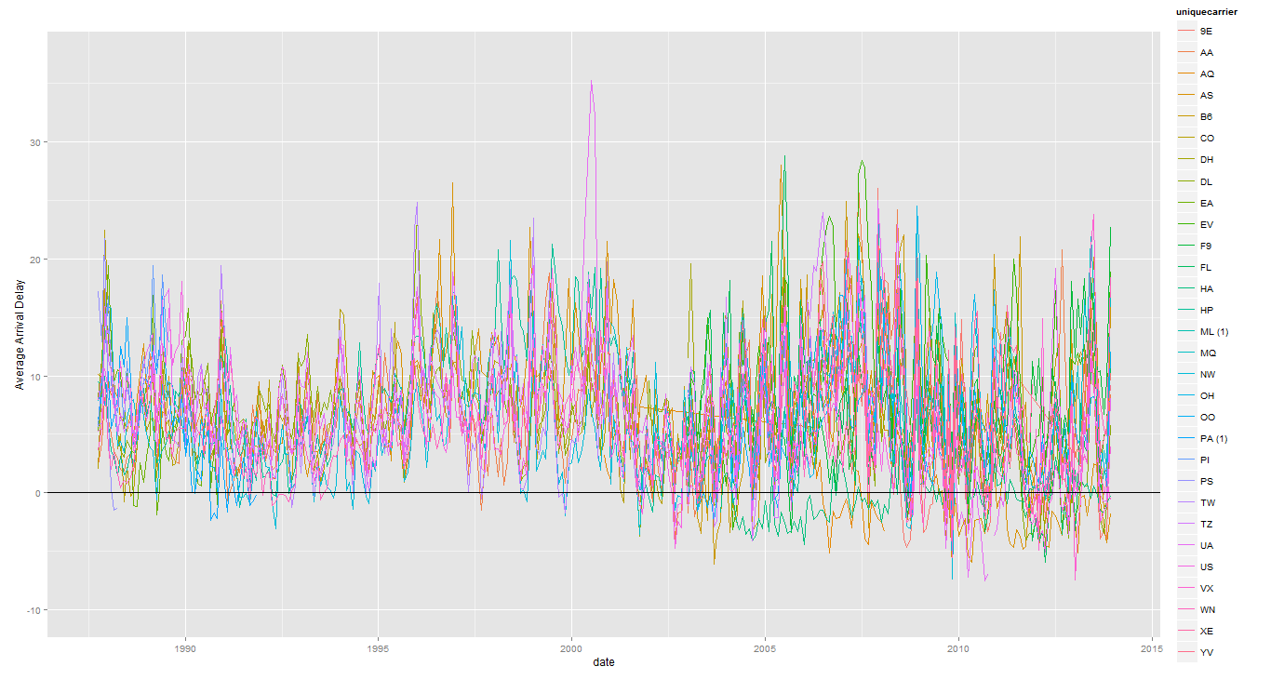

AVERAGE ARRIVAL DELAY ALL 27 YEARS